Name :Abimanyu M

Batch :2022 9615

Enrolment NO: EBEON0323767152

Merge Sort Algorithm

MERGE_SORT(arr, beg, end)

if beg < end

set mid = (beg + end)/2

MERGE_SORT(arr, beg, mid)

MERGE_SORT(arr, mid + 1, end)

MERGE (arr, beg, mid, end)

end of if

## END MERGE_SORT

## Working of Merge sort Algorithm

Given Array :

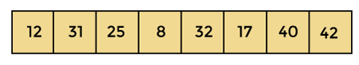

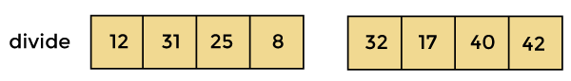

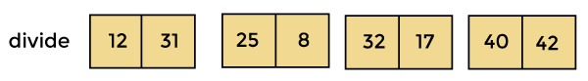

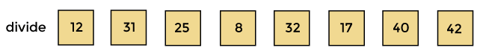

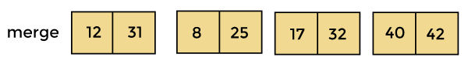

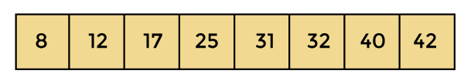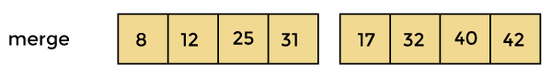

# Now, the array is completely sorted.

Quick Sort Algorithm

1. QUICKSORT (array A, start, end)
2. {
3. 1 **if** (start < end)
4. 2 {
5. 3 p = partition(A, start, end)
6. 4 QUICKSORT (A, start, p - 1)
7. 5 QUICKSORT (A, p + 1, end)
8. 6 }
9. }

# 

**Divide:** In Divide, first pick a pivot element. After that, partition or rearrange the array into two sub-arrays such that each element in the left sub-array is less than or equal to the pivot element and each element in the right sub-array is larger than the pivot element.

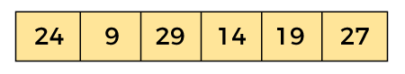**Conquer:** Recursively, sort two subarrays with Quicksort.

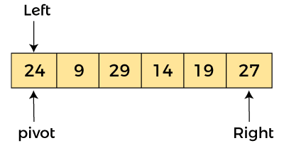

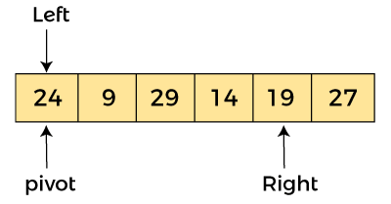

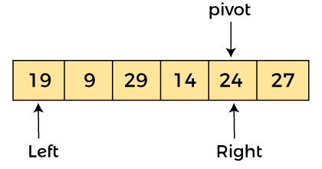

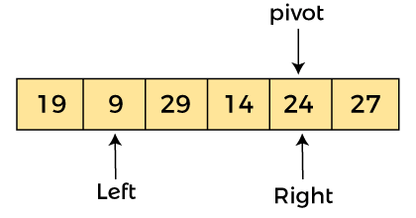

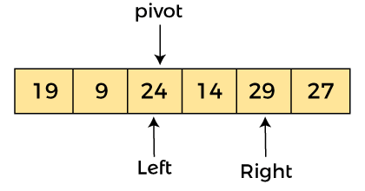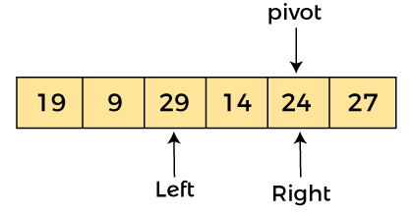

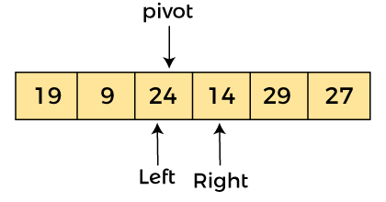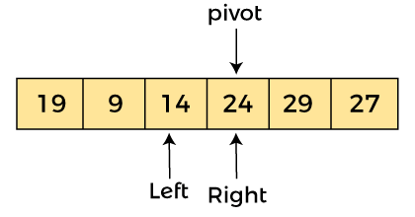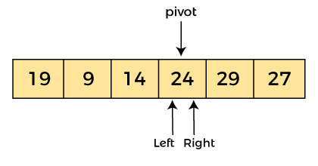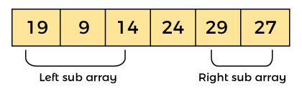

After sorting gets done, the array will be